**CURRICULUM VITAE**

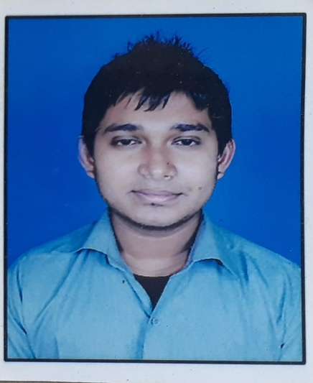SUDIP KUMAR ROY

CONTACT NUMBER: 8597706926

EMAIL ID : [007hnroyskyfall@gmail.com](mailto:007hnroyskyfall@gmail.com)

OBJECTIVE: To excel myself in a career where I can enhance my skills and competencies enabling me to set a trace record of contribution and achievement and get exposure in all aspects.

**PERSONAL INFORMATION:**

Name: Sudip Kumar Roy

Father’s Name: Subrata Kumar Roy

**PERMANENT ADDRESS:** VILL: Habaspur

P.O: Baranbaria

P.S: Dhantala

Dist: Nadia

Pin: 741504

West Bengal, India

**DATE OF BIRTH:** 03/11/1995

**NATIONALITY:**  INDIAN

**RELIGION:** HINDU

**SEX:** MALE

**MARITAL STATUS:** MARRIED

**EDUCATION QUALIFICATION:** 1. 12TH (WBCHSE) from Duttapulia Union Academy H.S

2. 10th (WBSE) from Duttapulia union Academy H.S

3.B.A 2nd Year Passed from Bagula Collage(Kalyani University)

4.Adavnce Diploma in Computer Accounts from RNNYC

5. 18 months Craft Course in Hotel Management from DSHM (MAKAUT)

**LANGUAGE KNOWN:**  ENGLISH, HINDI, BENGALI

**PASSPORT DETAILS:**

* Passport No: M8891424
* Place Of Issue: Kolkata
* Date of issue: 28/04/2015
* Date of Expiry: 27/04/2025

**WORKING EXPERIENCE:**

1. Worked in Vivanta By TAJ, Green Cove, Kovala,Kerala 6months as a Trainee.
2. Worked in Tango Beach Resort as a Steward for 8 months in Neil Island, Andaman
3. Worked in Hotel Sentinel as a Senior Waiter from 2017-2019 in Port Blair, Andaman
4. Worked in Silver Sand Beach Resort as a Trainee Captain from 2019-2021

In Havelock, South Andaman.

**DECLARATION:**

I here by declare that all the statements made by me, in the application are true and complete to the best of my knowledge, a belief and nothing has been concealed or suppressed and anything found, otherwise at any point of time. I shall be liable for any action ancluding disqualification.

DATE: 30-08-2021

PLACE: DUTTAPULIA